
Local Workforce Development Area Memorandum of Understanding and Infrastructure Funding Agreement

Template Guidance

Revised May 2023

Contents
Legal Authority 4
Development of the Memorandum of Understanding (MOU) 5
Life Cycle of an MOU 6
Sample MOU Development Timeline 7
Questions during MOU Development 8
Memorandum of Understanding Template Instructions 9
Infrastructure Funding Agreement Components 15
One-Stop Operating Budget 15
Infrastructure Funding Agreement 16
IowaWORKS One-Stop Center Types 16
One-Stop Partners Roles and Responsibilities 17
Local Board Responsibilities 19
Iowa’s MOU Shared Cost Framework 20
Step 1 – Identify all comprehensive and affiliated/specialized centers in the local area 21
Step 2 – Identify the partners engaged in or through each center. 22
Step 3 – Identify how each partner provides services/access in each center/in the system. 23
Step 4 – Identify one-stop operating costs, including infrastructure costs and additional costs. 26
Step 5 – Develop and agree to the one-stop operating budget that includes an infrastructure cost budget and additional cost budget. 31
Step 6 – Develop the cost allocation methodology, including cost pools and allocation bases. 32
Step 7 – Allocate actual costs by each partner’s proportionate use and relative benefit received. 36
Step 8 – Determine estimated partner contributions. 39
Step 9 – Prepare and agree to the sharing agreement. 41
Step 10 – Conduct a periodic reconciliation. 42
Step 11 – Modify infrastructure cost budget and/or cost allocation methodology, as appropriate. 42
Step 12 – Evaluate the existing process and prepare for the next program year. 43
Infrastructure Funding Mechanisms 44
Questions during MOU and IFA Development 46
One-Stop Operating Budget Workbook Instructions 47
Appendix I – Glossary of Key Terms 49
Appendix II – Supplemental Information for Attachment C 52
Title II- AEFLA Program 52
Title IV- Vocational Rehabilitation Services 53

Legal Authority
The Workforce Innovation & Opportunity Act (WIOA) sec 121(c)(1) requires the Local Workforce Development Board (Local WDB), with the agreement of the Chief Elected Official (in Iowa, known as the Chief Lead Elected Official), to develop and enter into a Memorandum of Understanding (MOU) between the Local WDB and the One Stop Partners, consistent with WIOA sec 121 (c)(2), concerning the operation of the one stop delivery system in a local workforce development area. This requirement is further described in the Workforce Innovation and Opportunity Act, Joint Rule for Unified and Combined State Plans, Performance Accountability, and the One Stop System Joint Provisions: Final Rule at 20 CFR 678.500, 34 CFR 361.500, and 34 CFR 463.500, and in Federal guidance.

Development of the Memorandum of Understanding (MOU)
The vision of the one-stop system is to align education, employment, and training program partners, while providing a seamless delivery of multiple services to individual customers. Joint funding is an essential foundation for an integrated service delivery system and is necessary to develop and maintain high standards of service. Our shared customers benefit from a coordinated approach to service design and delivery which enables them to access a comprehensive system of services rather than individual programs.
The MOU is an agreement developed through local discussion and negotiation. It is executed between the Local WDB and the One Stop system partners with the agreement of the Chief Lead Elected Official. The MOU identifies how the local IowaWORKS system operates and how the Partners coordinate and collaborate to deliver high quality integrated services.
The Local WDB has responsibility to ensure a collaboratively developed and compliant MOU exists for the local workforce development area. To ensure the development of the MOU, the Local WDB, or those acting on behalf of the Local WDB, convenes the partners to accomplish the task.
The MOU should align with the Local Plan which is also developed by the Local WDB. The Local Plan identifies overarching strategies and solutions for ensuring a skilled and ready workforce in the local area while the MOU outlines details of how the Partners provide those strategies. The two documents should be viewed as companion pieces which provide a full and complete picture of a robust set of workforce services in the local area. The One-Stop Operating Budget serves as the financial plan for the services and operating costs of the one-stop delivery system as envisioned and established in the MOU. As a required component of the MOU, the Infrastructure Funding agreement is an integral component of the overall one-stop operating budget.

Life Cycle of an MOU
The development of the MOU is a process and, as such, it requires planning, action, and follow through to ensure the final product is a true reflection of local negotiation and decision making. The Life Cycle highlighted below is provided as a guide for planning the work of the partners and to ensure the process is approached in a collaborative spirit and tone from the beginning. Prior to beginning the MOU process, it is necessary to identify the partner points of contact.

Kickoff
Consider hosting a kickoff meeting where all partners are invited to begin the MOU process. At this meeting, the timeline, template, and guidance should be introduced. partners can brainstorm or strategize how to approach the work.

Negotiations
During the negotiations stage of the process the partners discuss their services and how they collaborate to provide services in the local area. The negotiations involve decision making about how a partner provides a particular service or how a partner will move locations to join a Comprehensive Center. The facilitator for these conversations should ensure everyone has the opportunity to voice their thoughts and opinions.

Draft MOU
Once all parties have discussed these goals and expectations with each other, the Board chair or Board Staff creates an initial draft of the agreement and coordinates its editing and development with the partners. The development process may take some time as each party gets the opportunity to propose and negotiate changes until all parties agree to one version of the MOU.

Review/ Comments
Once a draft MOU has been completed, an open review and comment period is necessary to ensure all parties agree to the collaborative goals and processes that have been identified in the MOU. This is not a public comment period, but the opportunity for the partners to review and provide comment.

Final MOU
Upon agreement to the terms of the MOU, all parties sign the agreement. The MOU may specify that the agreement will either commence as soon as all parties have signed the MOU or on a specific date in the future.

Implementation
Implementation of the finalized MOU starts as noted in the agreement. All parties should follow the MOU and be aware of the process to notify other parties when modifications or changes are needed.

Evaluation
After the MOU is in force, there should be an evaluation on a regular basis to ensure achievement of the desired goals and that the terms of the agreement are still equitable.

Sample MOU Development Timeline

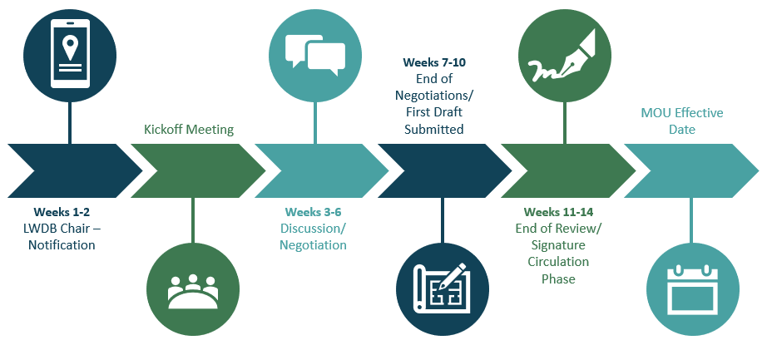

Weeks 1-2 – Local WDB Staff Sends – Preparation and Notification of Kickoff Meeting
- Review MOU Template and Guidance and develop list of questions, if needed.
- Develop draft communication plan with system partners and begin outreach.
- Develop draft timeline for MOU discussion, negotiation, and development.

Kickoff Meeting
- Partners attend MOU Statewide Kickoff Call.
- Discussions with Partners for any questions on MOU template and review guide.

Weeks 3-6 – Discussion/Negotiation
- Negotiations/ discussions with system partners
- Additional formal or informal meetings may take place, so long as they are conducted in an open and transparent manner, with pertinent information provided to all parties.

Weeks 7-10 – End of Negotiations and First Draft Submitted
- Draft MOU is complete and circulated to Partners for review.
- All partners should use this time to allow their respective legal departments to review the MOU for legal sufficiency.
- Local Board Chair or designee must ensure that all IowaWORKS center partners to the MOU are aware of the comments and revisions that are needed.

Weeks 11-14 – End of Review and Signature Circulation Phase
- Chair or designee circulates the finalized MOU and secure partner signatures.
- WIOA MOU is fully executed once all signatories have reviewed and signed, and a signed copy has been returned to all parties.
- If determined that a Partner is unwilling to sign the MOU, the Local Board Chair or designee must ensure that the dispute resolution process is followed.

MOU becomes effective and is implemented.

Questions during MOU Development
Should you have questions about the MOU guidance, MOU template, or the MOU process, please submit an email to the WIOA Core Partner Working Group at WIOAGovernance@iwd.iowa.gov.
Questions and answers will be posted regularly to the State WDB website.

Memorandum of Understanding Template Instructions
  - A section of the MOU template is listed here only if work is necessary by the local areas to complete that section.

Cover Page
Complete the section by adding name of Local WDB, local area, CLEO, and one-stop operator (OSO), as appropriate. For the OSO statement, select one of two options:
- Option 1- The Local WDB selected the One Stop Operator, {insert name of entity}, through a competitive procurement in accordance with the Uniform Guidance, WIOA and its implementing regulations, local procurement standards and rules, and IWD Policy # 1.4.7.3. All documentation for the competitive One Stop Operator procurement and selection process is published and may be viewed at {insert link to website}.

Introduction
This section is standard language and should remain the same. Local areas may choose to add to it; however, additional language should remain consistent with the overall theme and should not contradict any associated Federal law, regulations, or state agency issued guidance or policy.

Purpose
You may add to this list of purposes.

Vision Statement
Bringing partners to the table to negotiate and agree on MOU terms may not be an easy task. Collaboratively developing a strong vision statement that ties back to the goals and purpose of the MOU can help set the right tone for negotiations.
The vision statement can be the vision statement developed by the Local WDB. .

IowaWORKS System Structure
Complete the information in the paragraphs by inserting appropriate language regarding:
- Number of comprehensive centers and affiliate centers
- Name of local area
- Name of OSO
- Local WDB
- Local WDB website address

Attachment A-1- IowaWORKS Office Locations
- Identify each comprehensive center in the local area and provide accompanying information. Duplicate the table as needed.
- Identify each affiliate site in the local area and provide accompanying information. Duplicate the table as needed.

Attachment A-2: Partners’ Other Locations
- Identify the locations (not previously identified on Attachment A-1) in the local area where each partner provides services. Add lines to the table as needed. Between A-1 and A-2 every location where a partner provides services in the local area should be listed.

Attachment B: Partners/ Parties to this Agreement
Identify each partner program/party to this agreement. This is not the signature page for the MOU, but this will identify who will sign for each party. If the CLEO and Local WDB have approved any non-mandatory partners to participate in the local system, those non-mandatory partners should be identified on this list.

One-Stop Operator
Insert list of OSO duties as outlined in their contract’s scope of work. If one-stop operator has not been selected, include a statement which identifies that the OSO has not yet been selected but when selected, this MOU will be modified. Ensure that the reference to the OSO here aligns with the designation made on the cover page of the MOU.

Attachment C: Partner Services
Review this list of services and add to it any service that occurs in your local area that is not otherwise included. In making additions, ensure that you maintain the categories of career services (Basic and Individualized), Training, Youth, and Business. Do not delete from this list.

Attachment C-1: Career Services
Using the partner services listed in attachment C, complete matrix C-1 by identifying how each partner program is providing their services within the IowaWORKS system. Place the corresponding letter or number of the services from Attachment C in the appropriate “Method of Providing Service” column on C-1. One matrix must be completed for each comprehensive center in the local area.

Methods for providing access to each of the required services and alignment with Attachment C tables
- Option 1- Having a program staff member physically present at the American Job Center.
  - In Center Full Time
  - In Center Part Time
- Option 2- Having a staff member from a different partner program physically present at the American Job Center and appropriately trained to provide information to customers about the programs, services, and activities available through all partner programs.
  - Partner Program Provides Full Time
  - Partner Program Provides Part Time
- Option 3- Making available a direct linkage through technology to a program staff member who can provide meaningful information or services.
  - Direct Linkage
Method of Providing Service
Partner | Program | In Center Full Time | In Center Part Time | Partner Program Provides Full Time | Partner Program Provides Part Time | Direct Linkage

It is possible that a program could have more than one method of providing service in a single center.
For every career service not provided in center full-time, an explanation must be provided on attachment C-5 for how that service is available to customers.

Attachment C-2: Training Services
Using the partner services listed in attachment C, complete matrix C-2 by identifying how each Partner Program is providing their Training Services within the IowaWORKS system. Place the corresponding letter or number of the services from attachment C in the appropriate “Method of Providing Service” column on C-2. One matrix must be completed for each comprehensive center in the local area.
For every Training Service not provided in Center Full Time, an explanation must be provided on attachment C-5 for how that service is available to customers.

Attachment C-3: Youth Services
Using the partner services listed in Attachment C, complete matrix C-3 by identifying how each partner program is providing their Youth services within the IowaWORKS system. Place the corresponding letter or number of the services from attachment C in the appropriate “Method of Providing Service” column on C-3. One matrix must be completed for each comprehensive center in the local area.
For every Youth service not provided in Center Full Time, an explanation must be provided on attachment C-5 for how that service is available to customers.

Attachment C-4: Business Services
Using the partner services listed in Attachment C, complete matrix C4 by identifying how each partner program is providing their business services within the IowaWORKS system. Place the corresponding letter or number of the services on attachment C in the appropriate “Method of Providing Service” column on C-4. One matrix must be completed for each comprehensive center in the local area. Business Services includes customized services in accordance with partner programs’ statutory requirements and consistent with Federal Cost Principles.
For every Business service not provided in center full-time, an explanation must be provided on attachment C-5 for how that service is available to customers.

Attachment C-5: Services Not in Comprehensive or Affiliate Locations
For every partner program not providing services in center full time, list the program on C-5, along with accompanying information, and provide explanation of how that service is appropriately available to customers. Add lines as needed.

Attachment D: Referral Process
Outline the process partners will use to make referrals between each other. Add lines as needed to the table. It is required to include:
- Method for documenting referrals
- Method for tracking status of referrals
- Database(s) utilized.
- Maintaining accessibility of any forms utilized
If a form is utilized, check the box and attach the form.

Attachment E: Accessibility Plan
Outline how partners will ensure all four elements of accessibility- physical, virtual, communication, and programmatic- are met and maintained in the local system.
For more information regarding accessibility requirements, refer to WIOA section 188 and the WIOA Non-discrimination and Equal Opportunity Regulations (29 CFR part 38, Final Rule December 2, 2016, and the Americans with Disabilities Act (ADA).

Attachment F: Outreach Plan
Outline how partners will conduct collaborative outreach activities on behalf the IowaWORKS system.

Attachment G: Data Sharing Training Plan
Outline how partners will ensure all partner staff will be trained annually in the protection, use, and disclosure agreements governing Personally Identifiable Information (PII) and any other confidential data for all applicable programs. The outline should reference all Data Sharing Agreements and assurances utilized by partner agencies.

Attachment H: Dispute Resolution Process
Identify Step I in the local area Dispute Resolution Process. Included in the local process must be the right to appeal, first to the Core Partner Working Group, then to State Workforce Development Board. No local dispute may go directly to the State Workforce Development Board without first being addressed by the WIOA Core Partner Working Group.

Attachment I: Amendment/ Modification Process
Identify the process(es) for amending and modifying the MOU. In doing so, outline what changes will require an amendment or a modification. An amendment, which is adding new information, would only require theparties to review and agree to the elements of that MOU that changed. A modification is making a change to existing information. In your process, outline what changes will require a renewal to the MOU. A renewal is an overall review and re-do of the MOU. Substantial changes, such as changes in partners or a change in CLEO will require renewal. A renewal would require a review and approval of the entire MOU. Only individuals with signatory authority may authorize or request an amendment to the MOU.
For more information on Amendment, Modification, and Renewal Processes, refer to TEGL 16-16, RSA TAC 17-02, OCTAE Program Memo 17-4, One Stop Operations Guidance for the American Job Center Network.

Attachment J: Termination Process
Identify the process for terminating the MOU. Any termination process should be inclusive of the amendment process. Only individuals with signatory authority may authorize or request termination of the MOU.

Attachment K: Negotiations/ Meeting Summary
For each meeting (in person, virtual, or teleconference) held to discuss and/or negotiate the MOU, a written meeting summary must be completed to support all decisions and actions made by the partners. Duplicate this form as needed.

Signature Pages
Using the list of “Parties to this Agreement” in Attachment B as reference, one completed signature page must be attached for each Party.
You may add information to the signature page, but do not delete any information.
The MOU is to be signed by each party after discussions are complete and the party has reviewed the draft.

Effective Period
The effective period of this MOU is referenced in two places- this section and on each signature page. Ensure the proper box is checked and ensure consistency across the documents.

Infrastructure Funding Agreement Components

One-Stop Operating Budget
The one-stop operating budget is the financial plan that one-stop partners, the CLEO, and the Local WDB agree to in the MOU that is used to achieve the goals of delivering services in a local area.
The goal of the one-stop operating budget is to develop a funding mechanism that:
- Establishes and maintains the local workforce system and meets the needs of all customers
- Reduces duplication and maximizes program impact through Partner sharing of services and resources
- Reduces overhead costs for any one Partner by streamlining and sharing costs
- Ensures costs are appropriately shared by Partners by determining contributions based on proportionate use and relative benefit received
The one-stop operating budget contains cost categories that are specifically identified in TEGL: 17-16. Shared Operating Costs and Shared Services could include- initial intake, identification of appropriate services, assessment of needs, referrals to other One-Stop partners, appraisal of basic skills, or business services. Additional One-Stop Operating Costs must include applicable Career Services, such as development of an individualized employment plan, career planning, work experience and workforce preparation services.

Infrastructure Funding Agreement
The Infrastructure Funding Agreement (IFA), as a required component of the MOU, is an integral component of the overall one-stop operating budget that contains the infrastructure costs budget and identifies how Partners will share responsibility for the infrastructure costs. Key elements of the IFA are:
- The period of time in which the IFA is effective (which may be a different time period than the duration of the MOU)
- Identification of the infrastructure costs budget
- Identification of all One-Stop partners, CEO(s), and the Local WDB participating in the IFA
- A description of the periodic modification and review process
- Information on the steps the Local WDB, CEO(s), and One-Stop partners used to reach consensus, or the assurance the local area followed the state funding mechanism (SFM) process; and
- A description of the process to be used among partners to resolve issues related to infrastructure funding during the MOU duration period when consensus cannot be reached.

Infrastructure Costs
Infrastructure Costs are defined as non-personnel costs necessary for the general operation of the One-Stop center, including but not limited to:​
- Applicable facility costs (such as rent)​
- Costs of utilities and maintenance​
- Equipment (including physical modifications to the center for access, assessment-related products, and assistive technology for individuals with disabilities)​
- Technology to facilitate access to the one-stop center, including technology used for the center’s planning and outreach activities​
The Local WDB may consider common identifier costs as costs of one-stop infrastructure which may include signage, brochures, etc.

IowaWORKS One-Stop Center Types
The Iowa State Workforce Development Board has adopted the following definitions for IowaWORKS one-stop centers as defined in the IowaWORKS Center Certification Process Guidance:
- Comprehensive Center - Titles I and III are present full time with one other core partner present at least part time, and center provides access to all programs, services, and activities of partners not located in the center.
- Affiliated Center - Two or more core partners are present with at least one of the core partners present on a full-time basis.
- Satellite Center - Any location where one core or required partner is present on a permanent basis. Title I and Title III are not eligible to have stand-alone offices or be satellite centers.

Contribution Requirements by Center Types

 | Comprehensive | Affiliated/Specialized
Infrastructure Costs | ALL required one-stop partners regardless of co-location at that center | Only those partners engaged in the center
Additional Shared Costs | Only required partners who have agreed to share in the costs of one or more career services and/or any other shared service(s). | Only those partners engaged in the given center who agree to share in costs of career services and/or any other shared services.

One-Stop Partners Roles and Responsibilities

IowaWORKS Partners
The Iowa Workforce Development (IWD) is responsible for negotiating funding agreements with local WDBs pertaining to:
- WIOA Title I Adult, Dislocated Worker and Youth programs
- Migrant and Seasonal Farmworker programs (MSFW)
- Trade Adjustment Assistance activities (TAA)
- Jobs for Veterans State Grants programs
- Unemployment Insurance programs (UI)
- Reentry Employment Opportunities programs
- Wagner-Peyser Act Employment Service program
- Senior Community Service Employment program
The Iowa Vocational Rehabilitation Services (IVRS) is responsible for negotiating funding agreements with local WDBs pertaining to:
- Vocational Rehabilitation programs
The Iowa Department for the Blind (IDB) is responsible for negotiating funding agreements with local WDBs pertaining to:
- Vocational Rehabilitation programs
The Iowa Department of Education is responsible for negotiating funding agreements with local WDBs pertaining to:
- Adult Education and Family Literacy Act program
- Carl D. Perkins Career and Technical Education Act career and technical education programs at the postsecondary level
The Iowa Department of Human Rights is responsible for negotiating funding agreements with local WDBs pertaining to:
- Community Services Block Grant employment and training activities
The Iowa Department of Human Services is responsible for negotiating funding agreements with local WDBs pertaining to:
- Temporary Assistance for Needy Families (TANF) programs
Iowa’s workforce system partners also include:
- Job Corps
- YouthBuild
- Native American programs
- Housing and Urban Development employment and training activities

Partner Responsibilities
All partners, core and required, must:
- Provide access to their programs through the one-stop system
- Use their program’s funds to:
  - Provide career services
  - Maintain the one-stop system and jointly fund it
- Designating an individual(s) to act on its behalf in the negotiations, if applicable;
  - The individual(s) should be knowledgeable about the partner programs and activities and have the authority to commit the partner programmatically and financially
- Acting in good faith to negotiate infrastructure and additional costs in accordance with this guidance;
  - Additional partners are only required to contribute towards infrastructure costs. Additional partners MAY contribute towards additional costs but are not required to do so.
- Sign the Memorandum of Understanding with the local WDB
- Participate in the operation of the system

Local Board Responsibilities
The local WDB has the key responsibility for negotiating and developing the MOU, including the one-stop operating budget and the IFA. The board, utilizing its staff, must convene the partners to develop this task. One-stop partners as well as the CLEO must agree and sign the documents indicating such.
In developing the section of the MOU on one-stop infrastructure funding, the Local WDB and CLEO will:
- Ensure that the one-stop partners adhere to the guidance on one-stop delivery system infrastructure costs
- Work with one-stop partners to achieve consensus and informally mediate any possible conflicts or disagreements among one-stop partners
- Provide technical assistance to new one-stop partners and subrecipients to ensure that those entities are informed and knowledgeable of the elements contained in the MOU and the one-stop infrastructure costs arrangement
Local WDBs shall be responsible for the following:
- Acting as the convener for the purpose of negotiating the MOU and funding agreements
- Ensuring the one-stop partners adhere to all applicable guidance
- Working with the one-stop partners to achieve consensus and informally mediate any possible conflicts or disagreements
- Providing technical assistance to new one-stop partners and local grant recipients to ensure they are informed and knowledgeable about the elements contained in the MOU and funding agreements
- Developing a local one-stop center operating budget as a starting point for the negotiations
- Ensuring the negotiations include an agreed-upon budget and methodology for allocating infrastructure and additional costs amongst all partners
- Ensuring allocation methodology complies with the Uniform Guidance and is based on proportionate use and benefit received by each partner program
- Ensuring that all of the infrastructure and additional costs are paid according to the provisions of the MOU; and
- Informing IWD if there is an impasse.

Iowa’s MOU Shared Cost Framework
The development of the MOU is a process that requires planning, action, and follow through to ensure the final product is a true reflection of local negotiation and decision making. Iowa’s Shared Cost Framework is a tool to support the IFA development process and support local areas in implementation of their vision for service delivery.

Step 1 – Identify all comprehensive and affiliated/specialized centers in the local area
All centers need an MOU, which may either be developed separately for each center or under a combined MOU for the local area. Every local area must have at least one certified comprehensive center.
For each center, identify and record the name and title of center manager/OSO, address, operating hours phone number, email address, and website.


Case Study Step 1: Center List
Georgetown American Job Center is a comprehensive one-stop AJC.
One-Stop Center Name​ & Type | ​Georgetown Comprehensive American Job Center
Center Manager/ OSO Name, Title​ | ​Dr. Stephen Strange, Center Manager
Address​ | ​1234 Main Street  Anywhere, US 56789
Operating Hours​ | ​8:00am – 6:00pm, M, T  7:30am – 5:30pm, W, Th  7:30am – 12:00pm, F
Phone​ | ​(123) 456-7890
Email​ | ​email@georgetownajc.gov
Website​ | ​www.georgetownajc.gov

Step 2 – Identify the partners engaged in or through each center.
Each partner in the local area must be included on the MOU. The partner list should include those who are co-located in the center as well as those who are not co-located in the center. If the CLEO and the local WDB approved any non-mandatory partners to participate in the local system, those non-mandatory partners should be identified on this list. In addition to identifying the MOU signatories for each partner, it may be beneficial to identify partner fiscal representatives for the development of the one-stop operating budget and negotiation of shared costs.

Case Study Step 2: Partner List
Identify and record the program partner organizations and appropriate signatories for the Georgetown American Job Center.
Program​ | Partner  Organization​ | Authorizing  Statute​ | Signatory​ | Signatory's Contact  Information​
Chief Lead Elected Official | CLEO | WIOA Title I | Carol Danvers | email@cleo.gov  000-123-4567
Local Workforce Development Board, Chair | Local WDB | WIOA Title I | Steve Rogers, Chair | email@lwdb.org  000-123-4567
One Stop Operator | Open Door Solutions |  | Peggy Carter, OSO | email@oso.com  000-123-4567
Title I - Adult, | {insert name of service provider} | WIOA Title I | Loki Laufeyson, Project Lead | email@departmentofwork.gov  000-123-4567

Step 3 – Identify how each partner provides services/access in each center/in the system.
Identify the services provided by each partner per center. Methods of providing services identified in the law include:
- Having a program staff member physically present at the American Job Center Full Time or Part Time
- Having a staff member from a different partner program physically present at the American Job Center and appropriately trained to provide information to customers about the programs, services, and activities available through all partner programs.
- Making available a direct linkage through technology to a program staff member who can provide meaningful information or services.
As with the partner list in Step 2, services should be identified for both co-located partners as well as partners with services available through direct linkage.
Categorize the types of services provided by each partner:

Use a separate table per service type and per location to ensure accuracy and completeness.
Ensure that partners are use consistent language to identify their services. Develop a numbering system to identify the list of services which coordinate with methods of service delivery.
As partner services are identified, it is important to identify staffing and use of individual and shared space in terms of square footage. Data elements such as phone and internet connections must also be identified. This information is used later in the process for allocation methodology selection and determination of proportionate share per partner.

Case Study Step 3a: Partner Service List
In the Georgetown AJC, the Title I – Adult program provides Basic Career Services A-D in the center full time. The Job Corps program provides services A, B, C, E and L through Direct Linkage.
Partner | Program | Method of Providing Services
​ | ​ | In Center​ Full Time | In Center Part Time | Partner Provides​ Full Time | Partner Provides Part Time | Direct Linkage​
​Local Service Provider | Title I – Adult​ | A, B, C, D |  | ​
​National Job Corps | Job Corps | ​ |  |  |  | A, B, C, E, L

 | Basic Career Services Key
A. | Eligibility Determination
B. | Outreach, Intake, and Orientation to the information, services, programs, tools and resources available through the local workforce system
C. | Initial assessment of skill level(s), aptitudes, abilities, and supportive service needs
D. | In and out of area job search and placement assistance
E. | Provision of information on in demand sectors, occupations, or nontraditional employment
F. | Provision of employment/ workforce and labor market information
G. | Provision of performance information and program costs for eligible providers of training, education, and workforce services
H. | Provision of information on performance of the local workforce system
I. | Provision of information on the availability of supportive services and referral to such as appropriate
J. | Provision of information and meaningful assistance on Unemployment Insurance claim filing
K. | Provision of referrals and coordination of activities with other programs and services
L. | Information and assistance in applying for financial aid for training and education programs not provided under WIOA.

Case Study Step 3b: On-Site Engagement
The representation schedule reflects the on-site engagement of each of the partners at the Georgetown AJC. The schedule reflects staffing information, square footage data, and information regarding customers served and data connections used. This information is important to identify relative benefit when the cost allocation methodology is selected.
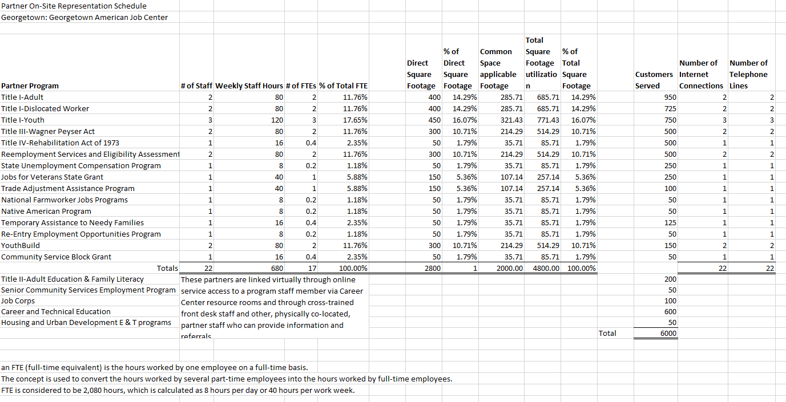

Step 4 – Identify one-stop operating costs, including infrastructure costs and additional costs.
Costs must be identified for all partners at each center and include an understanding of the frequency at which costs occur and who is paying for them. One-stop operating costs include infrastructure costs and additional costs. Additional costs must include applicable Career services and may include shared operating costs and shared services. Shared costs include all costs to operate a center and are not limited to infrastructure costs.
Infrastructure Costs | Career Services | Other Costs
Infrastructure Costs include non-personnel costs necessary for the general operation of the One-stop center, including but not limited to:​  - Facility costs - rent  - Utilities and maintenance​  - Equipment  - Technology to facilitate access to the One-stop center ​  - Common identifier costs | Applicable Career Services include the costs of the provision of career services in section 134(c)(2), as applicable to each program | Other Costs Shared services that are authorized for and may be commonly provided through One-stop partner programs, such as:​  - Initial intake​  - Identification of appropriate services ​  - Assessment of needs​  - Referrals to other One-stop partners​  - Appraisal of basic skills​  - Business services  - Cross training

Considerations for Identifying Costs
A customer’s experience at the center begins before they even go through the front door. Walking through a center and analyzing everything you can see from a customer’s perspective can help identify center costs. For example, signage visible from the street or parking lot directs a customer where to go. Outside of the building, the parking lot and/or landscaping may be maintained and have associated maintenance costs. External maintenance of the building could also include lighting in the parking lot, windows being cleaned, etc.
Career Services
- Are there any consultants and contract expenses?
- Are there any external workshops held at the center?
- Are there staff in the resource room?
- Are there expenses for resources and curriculum (e.g. technology for resume development, soft skill courses)?

Shared Service
- Does the center use front desk staff to triage customers or facilitate intake services to assist each customer in getting the best service in the center?
- How is this handled in the center?
- What staff perform this work and how is it allocated to all programs?
- Is there shared software used by all partners? Does each partner have similar but different software for the services being offered in the center?
- Are there trainings provided and utilized by all partners/customers in the center and how are they shared/allocated?

Infrastructure Costs
- Is there a lease for the building? Who holds the lease and who is leasee/leasor?
- Does the center use accessibility software and tools?
- How are general office expenses allocated among partners? Examples: postage, freight, printing, flyers/pamphlets, office supplies, legal notices/labor notifications, etc.
- Outreach services and how are they identified and allocated among partners? Do all programs agree on outreach for each of their programs?
- What is the phone count in the center? What is the internet drop connection for the center? How do phone bills and internet bills get paid? Are they included in the lease, or are they separate bills that are paid? Need to identify if there are phones and internet connections that are in common areas and shared among all partners.
- Is any equipment rented/leased? How is maintenance of the equipment and/or building shared among partners? How are the decisions for purchase of new equipment shared?
- What are the insurance costs for the center and how are they paid?
- For utilities and maintenance (electricity, janitorial services, landscaping/groundskeeping, pest control, trash, water, security) are they separate services or are they included in rent/lease?
- How is signage shared at the center?

Case Study Step 4a: Partner Cost List
Each partner must identify their costs by type at the center. This list of costs is used to develop a shared cost list and the one-stop operating budget. In the example below, the Good Jobs program cost list includes Career Services, Infrastructure Costs and Shared Costs for resource room staffing, assistive technology, office supplies, assessment software, electricity, janitorial services, and printing. This type of list is developed for all partners (co-located and not co-located) at the Georgetown AJC.
Good Jobs Program List of Costs at Georgetown AJC
Cost Category | Cost Item | Infrastructure Costs | Career Services Costs | Shared Services Costs | Total
Career Services | Resource Room Staffing |  | $170,000 |  | $170,000
Infrastructure Costs | Assistive Technology for Individuals with Disabilities | $10,000 |  |  | $10,000
Infrastructure Costs | Office Supplies | $40,000 |  |  | $40,000
Shared Services | Assessment Software/System |  |  | $10,000 | $10,000
Infrastructure Costs | Electricity | $18,000 |  |  | $18,000
Infrastructure Costs | Janitorial Services | $26,000 |  |  | $26,000
Infrastructure Costs | Printing | $17,000 |  |  | $17,000

Case Study Step 4b: Center Cost List
After partner cost lists have been developed for each program, the total center cost list is developed to reflect all costs across all categories and items that every partner is paying. In the example below, the costs for 3 partners (A, B, and C).

Cost Category | Cost Item | Partner A | Partner B | Partner C | Total
Infrastructure Costs | Office supplies | $15,000.00 | $30,000.00 | $5,000.00 | $50,000.00
Career Services | Resource room staffing | $10,000.00 | $20,000.00 | $5,000.00 | $35,000.00
Infrastructure Costs | Assistive technology for individuals with disabilities | $2,000.00 | $2,000.00 | $2,000.00 | $6,000.00
Infrastructure Costs | Signage | $1,500.00 | $1,500.00 | $1,500.00 | $4,500.00
Shared Services | Assessment software/system | $6,000.00 | $24,000.00 | $0.00 | $30,000.00
Infrastructure Costs | Electricity | $12,500.00 | $12,500.00 | $15,000.00 | $40,000.00
Infrastructure Costs | Janitorial services | $4,000.00 | $4,000.00 | $4,000.00 | $12,000.00
Infrastructure Costs | Printing | $1,000.00 | $3,000.00 | $25,000.00 | $29,000.00
 | Total | $52,000.00 | $97,000.00 | $57,500.00 | $206,500.00

Shared Cost Identification Process
- Partners prepare a list of costs to be shared
After all partners have identified their costs for the center, a list of shared costs is developed. The process of identifying costs and developing a shared cost list can support strategic conversations to improve collaboration among partners by eliminating duplication of services.

- Assign function/benefit statement to a negotiated list of costs to be shared
A benefit statement provides the documentation to support allowability and allocability of shared costs under partner programs. It also provides each partner with an understanding of how the shared costs will benefit its program.

- Assign a dollar value to each cost/group based on the cost needed to operate the center
The actual cost of services being shared should be determined first before partners identify the way they will satisfy their share of those costs. A dollar value can be assigned based on historical costs, a knowledgeable point of reference for comparable costs, or an estimate if needed.

Case Study Step 4c: Shared Cost List
A shared cost list is developed by the partners and benefit statements are developed to support allowability and provide a clear understanding of the benefit to partners. The dollar value is assigned to each cost.
Step 1 - Shared Cost | Step 2 – Assigned Function/Benefit of Cost | Step 3 – Assigned Dollar value to each Cost
Personnel costs associated with shared staff at welcome desk | Use staff for assistance for services and general information
Common Supplies and Equipment | Use supplies and equipment such as copiers, scanners, assistive technology for individuals with disabilities
Resource Center | Use Resource Room computers to conduct work searches and communicate with off-site programs.

Step 5 – Develop and agree to the one-stop operating budget that includes an infrastructure cost budget and additional cost budget.
Use the costs identified in Step 4 to categorize types of cost as:
- Career services
- Infrastructure costs
- Shared services
It is very important at this step to understand and appropriately categorize costs by type. In doing so, it may be possible to identify duplicative expenses at the centers and reduce duplication through alignment across partners or programs.

Case Study Step 5: One-Stop Budget
The one-stop budget for the Georgetown AJC includes all shared costs identified by type, category, pool, and item.
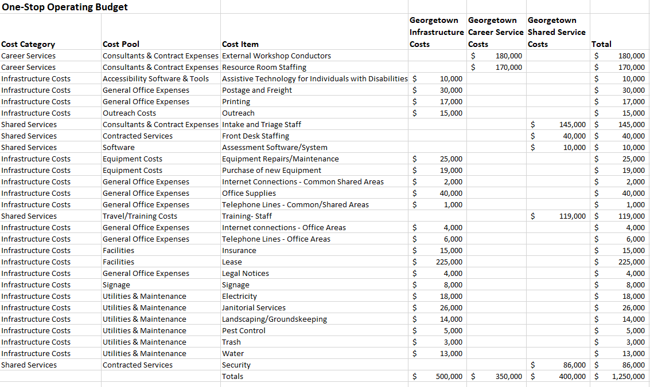

Step 6 – Develop the cost allocation methodology, including cost pools and allocation bases.

The cost allocation methodology is developed through collaboration across the partners in consideration of local factors and services at a center level. As described in 2 CFR 200.4, allocation is defined as the ‘‘process of assigning a cost, or a group of costs, to one or more cost objective(s), in reasonable proportion to the benefit provided or other equitable relationship.” Costs must be allowable, reasonable, necessary, and allocable to the partner program. WIOA does not prescribe a specific methodology to allocate costs among partners. Each local system is unique and has a different set of circumstances where costs are to be allocated. The local dynamics and structure should dictate the methodology used.

Process of Cost Allocation:

- Select methodology

Using the one-stop budget with identified costs to be shared, the following decisions should be made:
- Common cost item is selected for either:
  - Each line-item cost (space, utilities, etc.), or
  - Total infrastructure costs (total costs/base)
- Common bases are:
  - Square footage occupied by each Partner
  - Full time equivalent (FTE) of each Partner
  - Program enrollments under each program
  - Customer count (number of people who walk into the center, “door swings”)

- Identify Cost Pools
Categorize the individual cost items into cost pools such as:
- Facilities
- Telecommunications
- Resource scenter
- One-stop center general operations staff
- Shared equipment and supplies
- Career services

- Select allocation base
An allocation base is the method of documentation used to measure the extent of benefits received when allocating joint costs among multiple cost objectives. The allocation base or methodology that best fits the organizational structure must be agreed to by all partner programs. Partners may agree to use several bases for allocating various costs in the center(s). For proper reporting and utilization of federal funding, the bases used to allocate a particular cost must be consistent over time. The base utilized must be consistently applied to either the cost or group of costs for all partners located in the center. Allocation bases can be input-based or output-based.

Examples of Cost Pools and Possible Allocation Bases
Cost Pool | Possible Allocation Bases
​Facilities: Building rent, maintenance costs, utilities, tenant improvements, or any other similar costs related to the physical structure housing the one-stop center. | ​Square footage occupied by each partner agency as compared to the total space, workstation usage by partners as compared to total workstations.
Telecommunications: Monthly telephone costs, telephone system equipment, data lines, T-1 lines, and other similar costs. | Dedicated telephone units as compared to all units.
Information Technology: Shared equipment, software, IT maintenance costs, Internet access, and other similar costs. | Number of dedicated computers (including all necessary equipment) as compared to total.
Resource Center: Costs of shared equipment, displays, computer learning, specialized software for computer learning, furniture, copier, fax machine; may also include related staff costs. | Number of program participants or reportable individuals utilizing the resource center.
Common Intake System: Costs of developing common intake data formats, preparation and interview of customers, and similar costs. | Use of common data formats and data elements required for each program. Use of number of customer or participant records maintained by each partner program.
One-Stop Center Management Staff: Costs of the center director. | Number of partner program staff FTEs. Square footage of partner program benefit or number of program participants and reportable individuals served.
One-Stop Center General Operations Staff: Costs of the receptionist, staff of the resource center. | Number of partner program participants.
Shared Equipment and Supplies: Staff copier, fax, associated supplies, and furniture. | Usage by staff of each partner program. Occupancy (square footage) basis; numbers of staff workstations.
Career Services: Staff and benefit costs, development of common forms for case management, and similar costs. | Time distribution system (time sheets, work sampling, time and motion studies); numbers of clients eligible for specific program; weighted participation numbers.

Case Study Step 6: Cost Allocation Method
The Georgetown AJC partners uses multiple allocation bases across their shared costs including customers served, FTEs, and number of data connections.
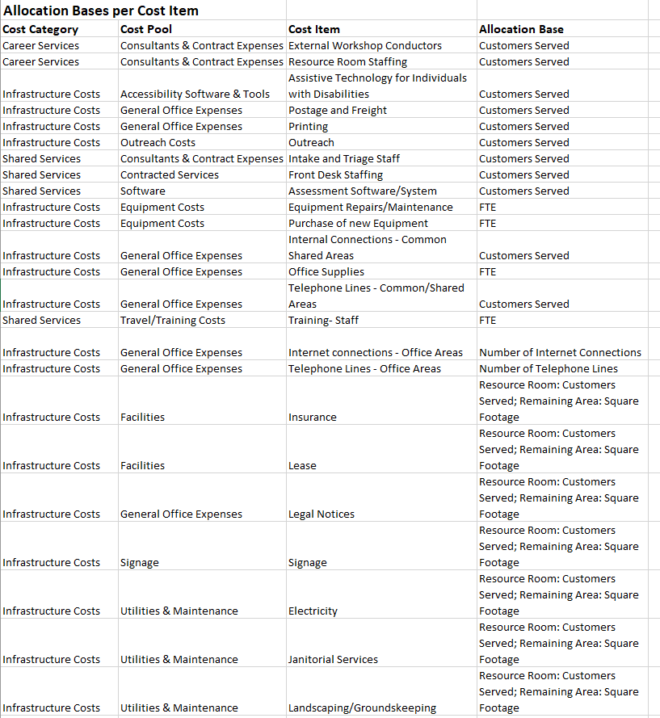

Step 7 – Allocate actual costs by each partner’s proportionate use and relative benefit received.
Based on the work completed in steps one through six , apply the cost allocation methodology to identify actual partner costs according to each partner’s proportionate use and relative benefit.

Proportionate Use
Proportionate use refers to a partner program contributing its fair share of the costs proportionate to:
- the use of the AJC by customers that may include reportable individuals and participants in its program at that AJC;
- the amount of square footage occupied by the partner program in the AJC; or
- another allocation base, such as staff FTEs, consistent with the Uniform Guidance.​
WIOA does not prescribe an exact methodology to be used to allocate infrastructure costs nor determine each partner’s proportionate share. Costs must be allocated in a way that is relative to the benefit that is received. Relative benefit does not require an exact or absolute measure of benefit, but instead measures a partner’s benefit using reasonable methods that are agreed to by all partners.

Relative Benefit
All partner’s contributions to the costs of operating and providing services within the one-stop center system must:
- Be relative to the proportionate use of the center and the benefits received,
- Adhere to the partner program’s federal authorizing statute, and
- Adhere to the Federal cost principles requiring that costs are reasonable, necessary, and allocable.
Customers access partner program services through the shared workforce development system and experience a relative benefit based on the alignment of service delivery through the system. Relative benefit is what shared system customers experience by accessing services through a system rather than through individual programs. Relative benefit is the result when costs are allocated based on an acceptable methodology that reflects the share of benefit received.​ Relative benefit is determined by selecting a base that aligns with the type of costs and program deliverables.​ Relative benefit is the outcome after all infrastructure and additional costs are allocated to programs according to a common base and reflect a partner’s share of costs.​

Cost Study Step 7: Cost Allocation
The Georgetown AJC is applying different cost allocation methodologies to identify partner costs.

Cost Allocation Example: Data Connections + Customers Served
Internet Connections: The total internet for the Georgetown AJC is $6,000 for one year. The cost is allocated across all partners. For partners located in the center, the number of direct connections is used to allocate costs, and for partners not co-located, an allocation base of customers served is used to allocate the cost.
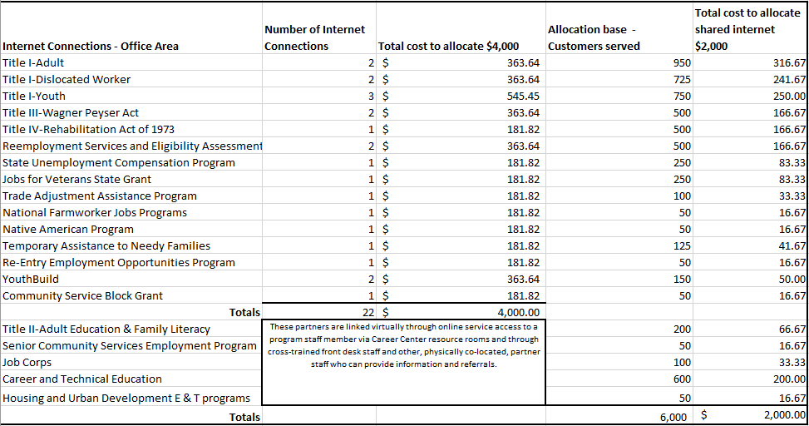

Cost Allocation Example: Number of Customers Served
At Georgetown AJC, staffing for the resource room as well as intake and triage services are allocated based on the number of customers served.

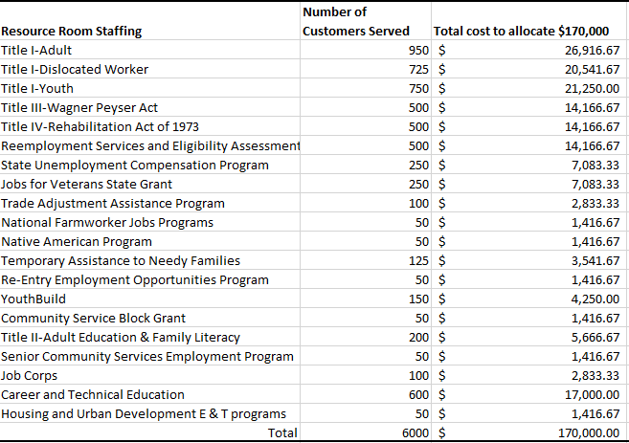
Resource Room Staffing: The total shared cost of Resource Room staffing at Georgetown is $170,000. It is allocated across the partners according to the number of customers served.

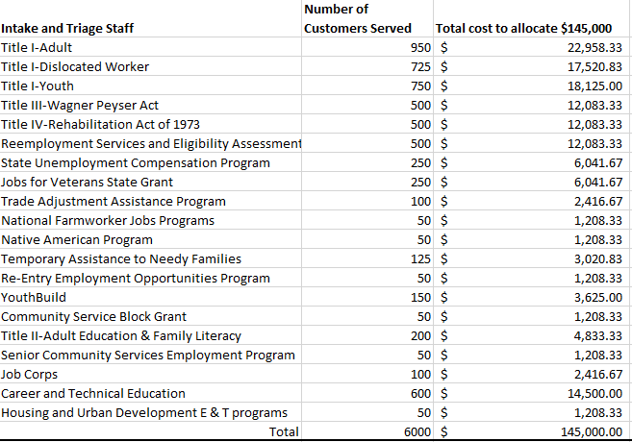
Intake and Triage Staff: Intake and Triage staffing is shared across partners for a total of $145,000 according to number of customers served.

Step 8 – Determine estimated partner contributions.
Once the costs have been identified, each partner determines the type of contribution utilized to cover their required costs.

Types of Contributions
Cash | Non-Cash | Third Party In-Kind
- ​Cash funds provided to the Local WDB or its designee by one-stop partners, either directly or by an interagency transfer or by a third party. | - Expenditures incurred by one-stop partners on behalf of the one-stop center; and  - Non-cash contributions or goods or services contributed by a partner program and used by the one-stop center | - Contributions of space, equipment, technology, non-personnel services, or other like items to support the infrastructure costs associated with one-stop operations, by a non-one-stop partner to  - Support the one-stop center in general; or  - Support the proportionate share of one-stop infrastructure costs of a specific partner.
Non-Cash and Third Party In-Kind contributions must be valued consistent with 2 CFR 200.306 to ensure they are fairly evaluated and meet the partners’ proportionate share. Partners must fairly value contributions on a periodic and annual basis.

Case Study Step 8: Estimated Partner Contributions
After the cost allocation methodologies have been applied, an estimate of partner contributions for the Georgetown AJC reflects the infrastructure costs, shared costs, and Career services cost estimates.
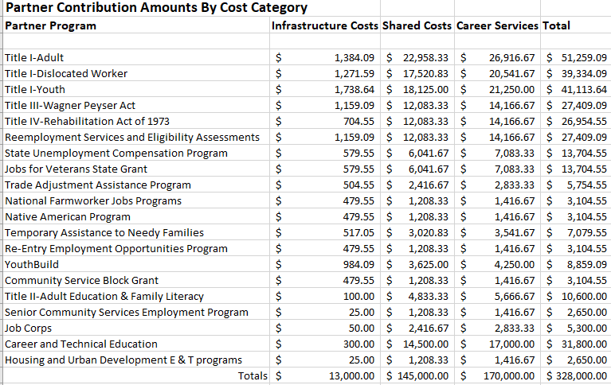

Example: In-Kind Allocation
Based on the allocations presented, Job Corps’ annual cost for the center is $5,300. The cash payment utilizing program funds is $3,000. They will make a third party in-kind contribution of furniture with a fair market value of $2,300. Job Corps’ proportionate share of the center’s costs have been fulfilled with these contributions.

Step 9 – Prepare and agree to the sharing agreement.
The IFA contains the infrastructure costs budget which is an integral component of the overall one-stop operations budget. The other components of the one-stop operating budget consist of applicable career services, shared operating costs, and shared services, which are considered additional costs. While each of these components covers different cost categories, an operating budget would be incomplete if any of these cost categories were omitted, as all components are necessary to maintain a fully functioning and successful local one-stop delivery system. Local WDBs, one-stop partners, and the CLEO should negotiate the IFA, along with additional costs when developing the operating budget for the local one-stop system.

Signatory Page
- The MOU must include signatures of individuals with authority to bind the signatories of the IFA, including all one-stop partners, chief lead elected official, and the local WDB.
- Changes in the one-stop partners or an appeal by a one-stop partner’s infrastructure cost contributions will require a renewal of the MOU.
The MOU must include description of the periodic modification and review process to ensure equitable benefit among one-stop partners. The MOU may be changed through processes of modification, amendment, or renewal. Triggers for these types of change may include the annual review, periodic reconciliation or request from one of the signatories
.

Step 10 – Conduct a periodic reconciliation.
Reconciliation is a required component of the IFA that is typically completed by the local grant recipient. All partner contributions, regardless of the type, must be reconciled on a regular basis (i.e., monthly or quarterly). Reconciliation should include a comparison of planned to actual expenses from the one-stop operating budget as well as actual expenses occurred vs. relative benefits received. The purpose of reconciliation is to ensure each partner program is contributing its proportionate share in accordance with the terms of the MOU.
- Partners need to identify the frequency at which reconciliation will be completed
- Partners need to develop a timeline of submission of documentation after the end of a quarter.
- Updates should be provided if there have been any changes in staff or customer participation numbers.
- The reconciliation is performed and if needed adjustments will occur for each partner.

​Considerations for Reconciliation
- Have there been any changes in staff or customer participation numbers?
- Have a partner’s services change in the center from full-time to part-time? From part-time to full-time?
- Have phones or computers been added or reduced in the center?
- Who will complete the reconciliation?
- How will invoices or adjustments be addressed with partners when necessary?
- What is the communication plan for dispute resolution regarding costs and invoicing?

Step 11 – Modify infrastructure cost budget and/or cost allocation methodology, as appropriate.
The MOU modification process will impact all components of the MOU, including the IFA.

Considerations for Modification
- Have there been any changes in the center(s)? If so, do they require modifications to the budget/cost allocation?
- Have partner benefits been evaluations in relationship to any service changes that would require changes to IFA budget/costs/allocations?
- Have there been any partner changes to the centers for inclusion in the IFA cost, budget, and allocation? (ex. Partners joining or leaving centers)
- Is the MOU modification sufficient for modification needs for the IFA?
- Are all partners aware of the communication plan for modifications to the MOU when a change is needed in the IFA?

Step 12 – Evaluate the existing process and prepare for the next program year.
The MOU, which includes the IFA, is a living documents that support ongoing discussion and continuous collaboration to optimize service delivery and program success. At a minimum, the MOU must be reviewed annually with periodic reconciliation of the One-Stop Operating Budget.

Considerations for Evaluation & Preparation
- Who is the signatory authority for each partner? Has the signatory authority changed since the document was previously signed?
- Are the any MOU/OSOB/IFA sections for changes?
- Is the partner list and list of partner services still accurate?
- What barriers or issues have been identified by partners for improvement?
- Have there been changes in the community that require service delivery to change?
- Have there been economic changes in the community that would require change in the MOU to better serve customers?

Infrastructure Funding Mechanisms
Under WIOA, infrastructure costs are funded either through the local funding mechanism (LFM) or the state funding mechanism (SFM). The LFM offers the most flexibility to local WDBs and one-stop partner programs to design and fund a one-stop delivery system in response to the needs of their local area by leveraging the funds and resources available to partners. The intent of the LFM is to encourage local areas to make a good-faith effort to reach consensus on infrastructure cost funding.
If the local WDB fails to reach consensus with all required partners regarding contributions to infrastructure costs, the SFM is triggered. Under the SFM, the Governor is required to calculate the statewide funding caps and the amount available for local areas that have not reached consensus, to determine partner contributions for infrastructure costs. The SFM is intended as a failsafe if local partners cannot come to consensus regarding infrastructure funding.

Local Funding Mechanism
The LFM is the first and ideal way to achieve successful agreement on cost sharing that aligns with the local vision for service delivery and unique needs of local partner programs and customers. The LFM promotes flexible, local control of fulfilling the local roles and responsibilities as described under WIOA.
Through the LFM, consensus regarding the IFA is reached by all required partners. Local WDBs, chief elected officials, and one-stop partners agree to the amounts and methods of calculating amounts each partner will contribute for one-stop infrastructure funding, including the infrastructure funding terms in the MOU. One-stop partner programs may determine what funds they will use to pay for infrastructure costs in accordance with the requirements in 20 CFR 678.720 and the partner’s authorizing statutes and regulations.

State Funding Mechanism
Failure by one required partner to reach consensus regarding infrastructure costs triggers the implementation of the state funding mechanism, even if all other required partners agree on the terms of the IFA. The SFM only applies to consensus related to infrastructure costs and is not triggered by career services or shared services costs. Native American programs are not subject to the SFM and a lack of agreement in infrastructure costs with Native American programs does not trigger the SFM.
Under the SFM, the Governor has the power to determine the infrastructure budget. The Governor may direct the local WDB, CLEO, and required partners into renegotiations. In this event, parties may come to agreement, sign a MOU, and proceed under the LFM.
It is to the benefit of the local area to preserve the flexibility of the LFM to exercise all available options and resources to achieve consensus before pursuing triggering the SFM. State partners and the US DOL Regional Staff team should be notified and engaged to support consensus building efforts to avoid utilization of the SFM .

If the local WDB, CLEO, and the local partners cannot reach consensus on the one-stop centers infrastructure costs and/or the amounts to be paid by each partner, the local WDB must notify the Governor of the impasse. Notification must be given in accordance with state policy.

Preferably, at the time the Governor is notified that consensus has not been reached, the local WDB Chair (or designee) must provide appropriate and relevant materials and documents used in the negotiations to the Governor. At a minimum, these materials should include:
- Local WIOA plan
- Cost allocation methodology or methodologies proposed by the partners to be used in determining the proportionate share
- Proposed amounts or budget to fund infrastructure costs
- Amount of partner funds included
- Type of funds (cash, non-cash, and third-party in-kind contributions) available
  - including all documentation on how partners valued non-cash and third party in-kind contributions consistent with 2 CFR 200.306
- Proposed or agreed on IowaWORKS Center budgets (for individual centers or a network of centers)
- Any partially agreed upon, proposed, or draft IFAs
- Additional materials as appropriate

The Governor will:
- Determine one-stop center infrastructure budget(s)
- Establish cost allocation methodology(s)
- Determine Partners’ proportionate shares,
- Calculate statewide caps
- Assess the aggregate total of infrastructure contributions as it relates to the statewide cap, and
- Adjust allocations
Once all determinations and calculations are completed, the Governor will notify the local WDB Chair (or designee) of the final decision and provide a revised IFA for execution by the parties.

The IFA becomes effective as of the date of signing by the final signatory.
Programs may appeal the Governor’s determinations of their infrastructure cost contributions in accordance with the process established under 20 CFR 678.750, 34 CFR 361.750, and 34 CFR 463.750.

Questions during MOU and IFA Development
Should you have questions about the IFA Guidance, IFA Template, or the IFA process, please submit an email to the WIOA Core Partner Working Group at WIOAGovernance@iwd.iowa.gov.

One-Stop Operating Budget Workbook Instructions
  - The One-Stop Operating Budget Workbook was developed to align to Steps 1-8 of Iowa’s MOU Shared Cost Framework.

Instructions
The workbook is set up to support the one-stop operating budget (OSOB) development for one IowaWORKS center. Make a copy of the workbook for each center in a local area. Workbook tabs include examples provided for reference in light blue boxes. Examples are not factored into formula calculations and may be deleted.

Summary
Use this section to track notes on the OSOB development process. Include a timeline of key development activities and process participants for future planning efforts. Notes in this section should also document decisions made that informed the budget approach including cost allocation methodology, cost reconciliation and allocation base updates, steps to reach consensus, and modification process.

Step 1 – Center List
This tab corresponds to MOU Attachment A-1. Note which center from the list for which the workbook and budget are being developed.
- Identify each comprehensive center in the local area and provide accompanying information. Duplicate the table as needed.
- Identify each affiliate site in the local and provide accompanying information. Duplicate the table as needed.

Step 2 – Partner List
The partner list corresponds to MOU Attachment B. The center list developed in the Step 1 tab can serve as a key for completing column A, reflecting center engagement.
- Identify each partner program/party to this agreement. Note if IFA signatories are different from MOU signatories.
- This is not the signature page for the IFA, but this will identify who will sign for each party and can serve as a tracking tool for signature collection.
- If the CLEO and local WDB approved any non-mandatory partners to participate in the local system, those non-mandatory partners should be included on this list.

Step 3a – Partner Service List
The partner service list corresponds to MOU attachment C and is inclusive of Basic Career Services, Training Services, Youth Services, and Business Services. These categories must be maintained in this list and additional categories may be added. Each service type matrix should be completed based on the accompanying key in Column J.

Step 3b – On-Site Engagement
The on-site engagement tab helps to identify data elements utilized by all partners in determining the proportionate benefit received by partners in the center. This tab is a helpful tool when conducting reconciliations. Partners should agree on when the data elements will be captured and updated.

Step 4a – Partner Cost List
Complete a table with a list of costs as identified by each partner and categorized by type of cost. One table should be completed for each partner – duplicate the table as needed.

Step 4b – Center Cost List
Complete a table with a list of costs as identified by each partner and categorized by type of cost. One table should be completed for each partner – duplicate the table as needed.

Step 4c – Shared Cost List
Develop a list of shared costs. Assign function/benefit and dollar value to each cost.

Step 5 – One-Stop Budget
After all costs are identified, a final budget for center operations may be developed and agreed upon by all partners.

Step 6 – Cost Allocation Method
Assign an allocation base methodology to each cost item.

Step 7 – Cost Allocation
Apply the chosen cost allocation method to the shared costs. Examples are provided to represent different cost allocation methodologies including customer count, square footage and a combined approach based on partner co-location.

Step 8 – Estimated Contributions
Determine total estimated contributions for each partner based on the shared cost list and allocation of shared costs in Steps 4c-7.

Appendix I – Glossary of Key Terms
Below is a list of common terms and definitions related to the process of developing a Memorandum of Understanding with an Infrastructure Funding Agreement and One-Stop Operating Budget.
- Additional Costs - Must include the costs of the provision of career services in Sec. 134(c)(2) applicable to each program consistent with partner program’s applicable Federal statutes and allocable based on cost principles of the Uniform Guidance at 2 CFR Part 200 and may include shared operating costs and shared services.
- Additional One-Stop partners - Other entities that carry out a workforce development program, including Federal, state, or local programs and programs in the private sector, may serve as additional partners in the American Job Center network if the local WDB and chief elected official(s) approve the entity’s participation.
- Allocation - Allocation means the process of assigning a cost, or a group of costs, to one or more cost objective(s), in reasonable proportion to the benefit provided or other equitable relationship. The process may entail assigning a cost(s) directly to a final cost objective or through one or more intermediate cost objectives.
- Cash contributions – cash funds provided to the local WDB or its designee by one-stop partners, either directly or by an interagency transfer or by a third party.
- Cost objective - Cost objective means a program, function, activity, award, organizational subdivision, contract, or work unit for which cost data are desired and for which provision is made to accumulate and measure the cost of processes, products, jobs, capital projects, etc. A cost objective may be a major function of the non-Federal entity, a particular service or project, a Federal award, or an indirect (Facilities & Administrative (F&A)) cost activity, as described in Subpart E—Cost Principles of this Part. See also §§ 200.44 Final cost objective and 200.60 Intermediate cost objective.
- Funding types - Funding for infrastructure costs and additional costs, such as shared costs and shared services, may be in the form of: (1) cash, non-cash, and third-party in-kind contributions; (2) funding from philanthropic organizations or other private entities; or (3) other alternative financing options, as described in WIOA sec. 121(c)(2)(A)(ii) and 20 CFR 678.715, 34 CFR 361.715, and 34 CFR 463.715.
- Infrastructure Costs - Infrastructure costs of AJCs are defined as non-personnel costs that are necessary for the general operation of the one-stop center, including: rental of the facilities; utilities and maintenance; equipment (including assessment-related and assistive technology for individuals with disabilities); and technology to facilitate access to the one-stop center, including technology used for the center’s planning and outreach activities (WIOA sec. 121(h)(4), 20 CFR 678.700(a), 34 CFR 361.700(a), and 34 CFR 463.700(a)).
- Infrastructure Funding Agreement – a required component of the MOU that contains the infrastructure costs budget.
- Memorandum of Understanding (MOU) – An agreement that identifies how a local system will operate and describes the coordination and delivery of high-quality integrated services as a result of local partner collaboration. The MOU is locally developed through discussion and negotiation and is executed between the local WDB and the one-stop system partners with the agreement of the CLEO .
- Non-Cash contributions – expenditures incurred by one-stop partners on behalf of the one-stop center; and non-cash contributions or goods or services contributed by a partner program and used by the one-stop center. Non-cash and third party in-kind contributions must be valued consistent with 2 CFR 200.306 to ensure they are fairly evaluated and meet the partners’ proportionate share. Partners must fairly value contributions on a periodic and annual basis.
- One-stop delivery system - The one-stop delivery system, known as IowaWORKS in the state of Iowa, brings together workforce development, educational, and other human resource services in a seamless customer-focused service delivery network that enhances access to the programs’ services and improves long-term employment outcomes for individuals receiving assistance. One-stop partners administer separately funded programs as a set of integrated streamlined services to customers. [20 CFR 678.300(a); 34 CFR 361.300(a); and 34 CFR 463.300(a)]
- One-Stop Operating Budget – The operating budget of one-stop centers is the financial plan to which the one-stop partners, CLEO, and local WDB in each local area have agreed in the MOU that will be used to achieve their goals of delivering services in a local area
- Proportionate use - a partner program contributing its fair share of the costs proportionate to: (1) the use of the one-stop center by customers that may include reportable individuals and participants in its program at that one-stop center; (2) the amount of square footage occupied by the partner program in the one-stop center; or (3) another allocation base consistent with the Uniform Guidance.
- Relative benefit -In determining the proportionate share, the “relative benefit” received from participating in the one-stop delivery system is another step in the cost allocation process. Determining relative benefit does not require partners to conduct an exact or absolute measurement of benefit, but instead to measure a partner’s benefit using reasonable methods.
- Shared operating costs and shared services - Shared operating costs and shared services costs may include costs of shared services that are authorized for and may be commonly provided through the one-stop partner programs, including initial intake, assessment of needs, appraisal of basic skills, identification of appropriate services, referrals to other one-stop partners, and business services.
- Third Party In-Kind contributions – contributions of space, equipment, technology, non-personnel services, or other like items to support the infrastructure costs associated with one-stop operations, by a non-one-stop partner to support the one-stop center in general; or support the proportionate share of one-stop infrastructure costs of a specific partner. Non-cash and third party in-kind contributions must be valued consistent with 2 CFR 200.306 to ensure they are fairly evaluated and meet the partners’ proportionate share. Partners must fairly value contributions on a periodic and annual basis.

Appendix II – Supplemental Information for Attachment C
To ensure core partner agency staff across Iowa identify services consistently, please refer to the following charts as you complete Attachments C-1, C-2, C-3, and C-4.

Title II- AEFLA Program
Career and Training Services Applicable to AEFLA | Category of Service
Outreach, intake, and orientation information | Career
Initial assessment of skill levels including literacy, numeracy, and English language proficiency, as well as aptitudes, abilities, and supportive services needs | Career
Referrals to and coordination of activities with other programs and services | Career
Provision of performance information and program cost information on eligible providers of education, training, and workforce services by program and type of provider | Career
Provision of information on availability of supportive services or assistance and appropriate referrals including-  - childcare  - child support  - medical or child health assistance available through the State’s Medicaid program and CHIP  - SNAP benefits  - EITC (Earned Income Tax Credit)  - assistance under TANF and  - other supportive services and transportation | Career
Integrated education and training (IET) programs | Training

Title IV- Vocational Rehabilitation Services
Vocational Rehabilitation Service | Category of Service | RSA-911 Data Element Number(s)
Job Exploration Counseling | Career | 97-102
Work Based Learning Experiences | Training | 103-108
Counseling on Enrollment Opportunities | Career | 109-114
Workplace Readiness Training | Career | 115-120
Instruction in Self Advocacy | Career | 121-126
Graduate College or University | Training | 129-135
Four Year College or University Training | Training | 136-142
Junior or Community College Training | Training | 143-149
Occupation or Vocational Training | Training | 150-156
On the Job Training | Training | 157-163
Registered Apprenticeship Training | Training | 164-169
Basic Academic Remedial or Literacy Training | Training | 170-176
Job Readiness Training | Training | 177-183
Disability Related Skills Training | Training | 184-190
Miscellaneous Training | Training | 191-197
Randolph-Sheppard Entrepreneurial Training | Training | 198-204
Customized Training | Training | 205-211
Assessment | Career | 212-218
Diagnosis and Treatment of Impairment | Career | 219-225
Vocational Rehabilitation Counseling and Guidance | Career | 226-232
Job Search Assistance | Career | 233-239
Job Placement Assistance | Career | 240-246
Short Term Job Supports | Career | 247-253
Supported Employment Services | Career | 254-260
Information and Referral Services | Career | 261-267
Benefits Counseling | Career | 268-274
Customized Employment Services |  | 275-281
Extended Services |  | 282-286

20 CFR 678.430
20 CFR 678.305(d) and TEGL 16-16
20 CFR 680.200
20 CFR 678.435
US DOL Sample MOU and Infrastructure Costs Toolkit (2017)
20 CFR 678.755, 34 CFR 361.755, and 34 CFR 463.755
WIOA Sec. 121(h)(4) and 20 CFR 678.700
IowaWORKS Center Certification Process Guidance (2022)
TEGL 17-16 Infrastructure Funding of the One-Stop Delivery System
20 CFR 678.420
20 CFR 678.715(b)
2 CFR 200.4 “Allocation”
TEGL: 17-16 Attachment I: Examples of Cost Pools and Possible Allocation Bases
TEGL: 17-16 Attachment II: Paying for the One-Stop Delivery System
TEGL 17-16 Infrastructure Funding of the One-Stop Delivery System
Sample Memorandum of Understanding for Partners of the American Job Center Network
Sample Memorandum of Understanding for Partners of the American Job Center Network
Sample Memorandum of Understanding for Partners of the American Job Center Network
TEGL: 17-16 Attachment II: Paying for the One-Stop Delivery System
Sample Memorandum of Understanding for Partners of the American Job Center Network
TEGL: 17-16 Infrastructure Funding of the One-Stop Delivery System
TEGL: 17-16 Infrastructure Funding of the One-Stop Delivery System
TEGL: 17-16 Infrastructure Funding of the One-Stop Delivery System
20 CFR 678.500(a)​
TEGL: 17-16 Attachment II: Paying for the One-Stop Delivery System
Sample Memorandum of Understanding for Partners of the American Job Center Network
TEGL: 17-16 Infrastructure Funding of the One-Stop Delivery System
TEGL: 17-16 Infrastructure Funding of the One-Stop Delivery System
TEGL: 17-16 Infrastructure Funding of the One-Stop Delivery System
Sample Memorandum of Understanding for Partners of the American Job Center Network
TEGL: 17-16 Attachment II: Paying for the One-Stop Delivery System
USDOE RSA-TAC-17-01

